Department | AIML
Course Code / Course Name | DSA0602/ Data Handling and Visualization
Experiment | Data Visualization using R
Name | YASHIKA.R
Register Number | 192525102
Date | 20/10/2026
Day | Tuesday
SET 27

Experiment 1: Scatterplot matrix of health indicators
Aim: To inspect pairwise relationships among Age, BMI, blood pressure and cholesterol.
Algorithm: Create the numeric data frame and use pairs() to plot all pairwise combinations.
R Program:
patients <- data.frame(
Age = c(25,40,55,35,60),
BMI = c(22,28,30,26,32),
BP = c(120,135,145,130,150),
Cholesterol = c(180,210,240,200,260)
)
pairs(patients,
main = "Scatterplot Matrix of Patient Health Indicators",
pch = 19, col = "steelblue")
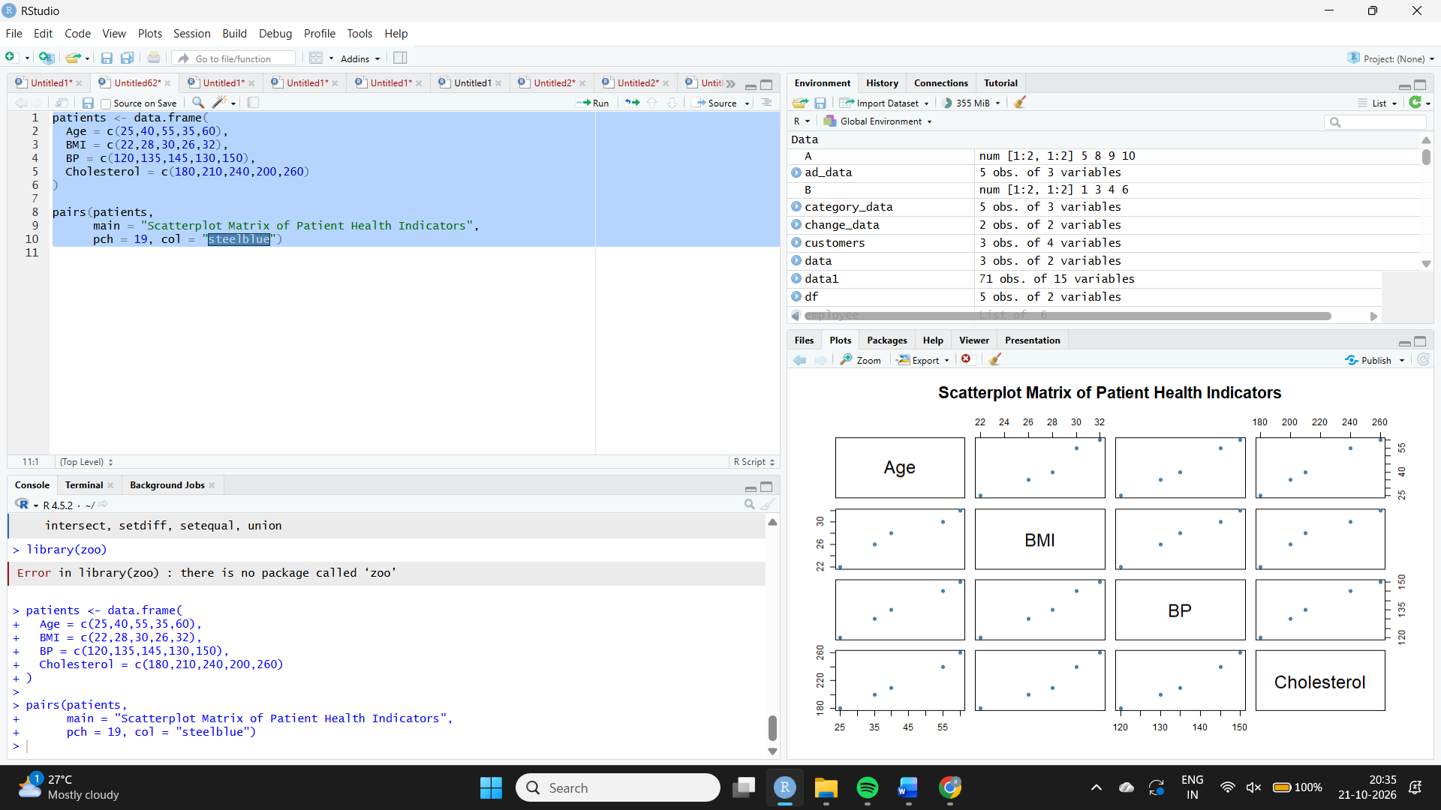
Expected output: A matrix of scatterplots comparing each pair of variables.
Result / Interpretation: Age, BMI, BP and Cholesterol generally rise together in this five-person sample. The apparent relationships are strong visually, but the sample is very small and cannot establish clinical risk or causation.
Experiment 2: Q-Q plot and ECDF for cholesterol
Aim: To assess cholesterol distribution and compare it with a theoretical normal distribution.
Algorithm: Create cholesterol values; draw a normal Q-Q plot and an empirical cumulative distribution function.
R Program:
cholesterol <- c(180, 210, 240, 200, 260)
par(mfrow = c(1, 2))
qqnorm(cholesterol, main = "Normal Q-Q Plot: Cholesterol",
pch = 19, col = "steelblue")
qqline(cholesterol, col = "red", lwd = 2)
plot(ecdf(cholesterol),
main = "ECDF of Cholesterol",
xlab = "Cholesterol", ylab = "Cumulative Proportion",
verticals = TRUE, do.points = TRUE,
col = "darkgreen", lwd = 2)
par(mfrow = c(1, 1))
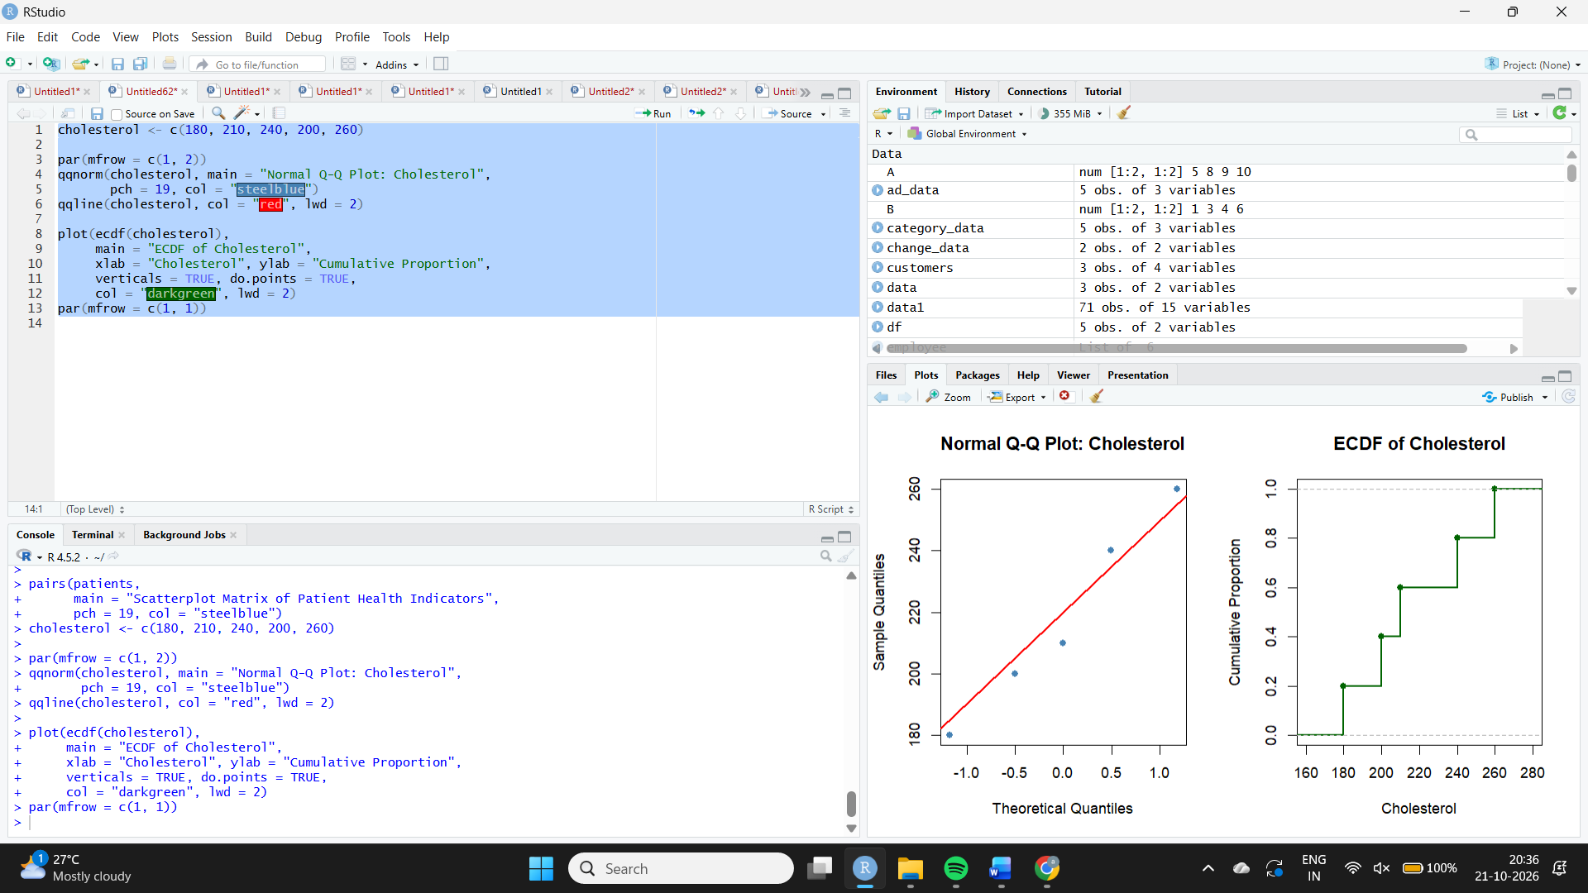
Expected output: A normal Q-Q plot and an ECDF step curve.
Result / Interpretation: Five values are insufficient for a reliable normality assessment. The Q-Q plot can show deviations from a straight line, while the ECDF shows the cumulative proportion at each cholesterol value. Do not claim a definite skewness pattern from this sample alone.
Experiment 3: Bar chart of average health indicators
Aim: To calculate and compare average Age, BMI, BP and Cholesterol values.
Algorithm: Calculate each variable mean; put indicators and means into a summary data frame; plot a colored bar chart.
R Program:
library(ggplot2)
patients <- data.frame(
Age = c(25,40,55,35,60),
BMI = c(22,28,30,26,32),
BP = c(120,135,145,130,150),
Cholesterol = c(180,210,240,200,260)
)
avg <- data.frame(
Indicator = c("Age", "BMI", "BP", "Cholesterol"),
Average = c(mean(patients$Age), mean(patients$BMI),
mean(patients$BP), mean(patients$Cholesterol))
)
print(avg)
ggplot(avg, aes(Indicator, Average, fill = Indicator)) +
geom_col(show.legend = FALSE) +
geom_text(aes(label = round(Average, 1)), vjust = -0.4) +
labs(title = "Average Patient Health Indicators",
x = "Health Indicator", y = "Average Value") +
theme_minimal()
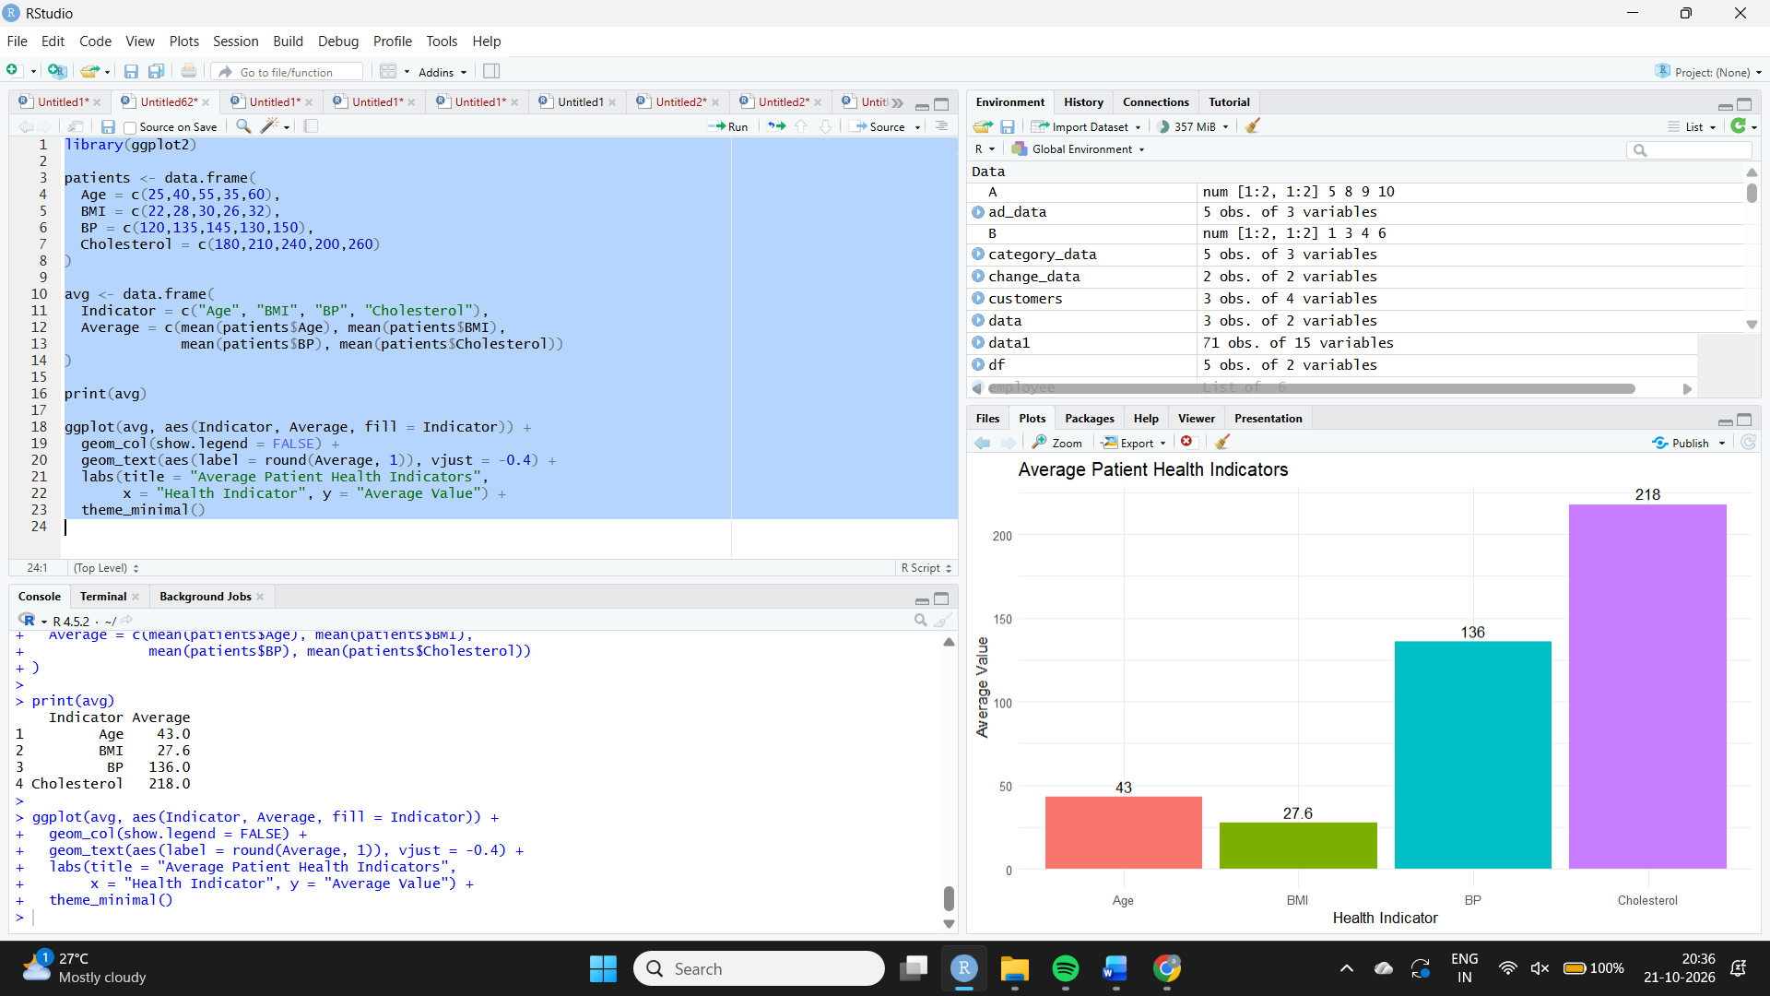
Expected output: Average Age = 43; BMI = 27.6; BP = 136; Cholesterol = 218.
Result / Interpretation: The chart compares numeric averages but the units differ, so bar heights should not be compared directly across indicators. Clinical risk assessment requires appropriate medical thresholds and context.
Experiment 4: Interactive patient heatmap in Tableau
Aim: To highlight patient indicators and explore patients by age.
Algorithm: Import patient data; create a heatmap; use a risk-related color scale; add an Age filter and tooltips.
Procedure (Tableau): Enter Patient_ID, Age, BMI, BP and Cholesterol into a data source. Create a heatmap using Patient_ID on Rows and the indicator names/values in the view (Measure Names and Measure Values). Use color to highlight higher values and show all four indicators in tooltips. Add Age as a range filter. If a clinical risk label is required, define it using a clinician-approved rule rather than inventing one.
Expected output: An interactive heatmap with an Age filter and hover tooltips showing the health indicators.
Result / Interpretation: P3 and P5 have elevated values across several supplied measures; P5 is oldest and has the highest BMI, BP and cholesterol, while P3 has the second-highest values for several measures. This is a data-pattern observation, not a diagnosis or a validated clinical risk score.

